DEPARTMENT OF COMPUTER SCIENCE
SCHOOL OF SCIENCES
MCA SPECIALIZATION PROJECT REPORT
(MCA583-4)
CIA - 1 STATUS REPORT
SafeRoute AI: An AI-Powered Road Accident Hotspot Prediction System with Google Maps Visualization and Fallback Vector Mapping
SUBMITTED TO:
Dr. Ramesh Chandra Poonia
Associate Professor, School of Sciences
SUBMITTED BY:
Gracia Sharon Jopson
Register Number: 25225011
Academic Year: 2025 - 2026

Table of Contents
CHAPTER 1 - INTRODUCTION ....................................................... 3
1.1 Purpose of the Document .................................................. 3
1.2 Project Scope & Target Boundaries ........................................ 4
1.3 Definitions, Acronyms, and Abbreviations ................................. 5
1.4 Technical & Scientific References ........................................ 6
1.5 Document Overview & Structure ............................................ 7
CHAPTER 2 - OVERALL DESCRIPTION ................................................ 8
2.1 Product Perspective & Context ............................................ 8
2.2 Major Product Functions .................................................. 9
2.3 Detailed User Characteristics & Personas ................................ 10
2.4 Runtime & Database Operating Environment ................................ 12
2.5 Architectural, Design, and Implementation Constraints ................... 13
2.6 Project Assumptions and System Dependencies ............................. 14
CHAPTER 3 - SPECIFIC REQUIREMENTS ............................................. 15
3.1 Functional Requirements (FR1 - FR12) .................................... 15
3.2 Non-Functional Requirements (Performance, Reliability, Security) ........ 21
3.3 External Interface Requirements (UI, Software, Hardware) ................ 23
CHAPTER 4 - SYSTEM DESIGN & DATA ARCHITECTURE ................................. 26
4.1 System Architecture & Decoupled Containers Layering ..................... 26
4.2 User Journey & Process Workflow Flowchart ............................... 28
4.3 Functional Module Decomposition & Interactions .......................... 30
4.4 Database Schema & Table Specifications .................................. 32
CHAPTER 5 - FUTURE PRODUCT EVOLUTION ROADMAP .................................. 36
CHAPTER 6 - RETROSPECTIVE CONCLUSION .......................................... 38

CHAPTER 1 - Introduction
1.1 Purpose of the Document
This Software Requirement Specification (SRS) document details the complete functional, non-functional, operational, and architectural specifications for SafeRoute AI: An AI-Powered Road Accident Hotspot Prediction System with Google Maps Visualization and Fallback Vector Mapping. The primary purpose of this specification is to establish a contract defining the project scope, technical requirements, algorithms, and validation rules for engineers, QA analysts, and project managers.
By mapping out all aspects of user authentication, GIS-based coordinate visualizations, Random Forest ML pipeline servings, and administrator dashboards, this SRS acts as the source of truth for the entire software engineering lifecycle. It provides developer specifications to verify correctness before code execution begins, ensuring that all components meet the required specifications.
The system addresses a critical gap in smart city infrastructure and daily travel safety. By shifting from historical reactive crash records to proactive real-time safety risk predictions based on weather, traffic, and environmental features, SafeRoute AI empowers commuters to optimize their journeys and assists emergency responders in positioning patrol units at high-risk hotspots before collisions happen.
1.2 Project Scope & Target Boundaries
SafeRoute AI is built as a single-page web client (React.js using Tailwind CSS styling and Framer Motion transitions) interacting with an asynchronous FastAPI backend ASGI service. The scope of this project encompasses the following areas:
- Stateless Authentication: Standard Drivers and Traffic Planners log in securely. The system uses secure JSON Web Tokens (JWT) signed with HMAC-SHA256, storing JTIs in an invalidated blocklist upon logout to prevent replay attacks.
- Google Maps Integration: Integrates the Google Maps JavaScript API (via a custom MapLoader service) configured with custom dark styling, glowing circular danger nodes representing accident hazards, and interactive information window popups. Coordinates are resolved through Geocoding.
- GIS Fallback Map: If the Google Maps JavaScript SDK fails to load (due to internet loss, billing limits, or API key errors), the client automatically renders a grid-based SVG fallback map using coordinate offsets, ensuring prediction availability.
- Risk Input Form: Features custom sliders and dropdowns allowing commuters to select parameters: Weather (Clear, Rainy, Snowy, Foggy, Windy), Traffic Density (Low, Medium, High, Jammed), Road Type (Highway, Arterial, Local, Expressway), Average Speed (km/h), and Time of Day (Morning, Afternoon, Evening, Night).
- ML Inference Pipeline: Queries a pre-trained Random Forest Classifier model binary to output a prediction score (0-100), risk category (Low, Medium, High, Critical), and confidence rating percentage.
- Interactive Charts: Provides custom donut and area charts (using Chart.js wrappers) illustrating the user's prediction distribution categories and risk trends over time.
- Admin Datasets & Retrainer: Enables administrators to upload new CSV datasets, performs multipart uploader size checks (<50MB), schema validation, checksum verification (SHA-256), and triggers retraining. Candidate models are promoted to production only if F1-scores improve and latency complies with the SLA.
Out of scope for this version of SafeRoute AI are real-time GPS turn-by-turn navigation guidance, live traffic API integrations (like TomTom or HERE Maps API), computer vision video processing of municipal CCTV feeds, and mobile applications (iOS/Android). The scope is strictly focused on a responsive web dashboard exposing local prediction services and administrative dataset management.
1.3 Definitions, Acronyms, and Abbreviations
The following table defines the technical acronyms, abbreviations, and variables used throughout this SRS document to ensure uniform terminology:
Term / Acronym | Description / Definition
SRS | Software Requirement Specification - This technical specifications document.
FastAPI | Asynchronous, high-performance web framework for Python REST API development.
JWT | JSON Web Token - Cryptographically signed token for stateless authentication claims.
JTI | JWT ID - Unique token identifier stored in the blocklist to prevent session reuse.
CORS | Cross-Origin Resource Sharing - Security rules restricting resource requests between domains.
HSTS | HTTP Strict Transport Security - Security header forcing HTTPS connections.
CSP | Content Security Policy - Security rules restricting executable scripts origins.
Random Forest | Supervised machine learning ensemble method combining decision trees for classification.
SLA | Service Level Agreement - Metric constraints defining target performance (e.g. inference under 200ms).
SVG | Scalable Vector Graphics - XML-based vector graphics format used here for offline mapping.
SHA-256 | Secure Hash Algorithm - Cryptographic hash function used to verify file integrity.
Framer Motion | React animation library used for smooth page transitions and skeleton layouts.
SQLite / Postgres | Persistent relational database engines managed via SQLAlchemy ORM.
1.4 Technical & Scientific References
- IEEE Std 830-1998, IEEE Recommended Practice for Software Requirements Specifications.
- World Health Organization (WHO), Global Status Report on Road Safety - outlining the importance of proactive safety measures.
- FastAPI Framework Core Documentation: https://fastapi.tiangolo.com/ - specifications for async routers and dependency injections.
- Scikit-Learn Ensemble Methods: https://scikit-learn.org/stable/modules/ensemble.html - documentation on Random Forest hyperparameters.
- Google Maps JavaScript API Guidelines: https://developers.google.com/maps/documentation/javascript/ - marker overlays styling specifications.
- OWASP API Security Top 10 Reference Guide - resource for JWT session invalidation and rate-limiting specifications.
1.5 Document Overview & Structure
This SRS document is structured as follows. Chapter 1 introduces the project, scope, terminology, and reference publications. Chapter 2 provides a high-level overview of the application's perspective, main functions, user personas, operating environments, and design constraints. Chapter 3 defines the functional requirements (FR1-FR12) and quality attributes. Chapter 4 presents the detailed system design, including C4 component diagrams, workflows, module structures, ER diagrams, and relational database table schemas. Chapter 5 outlines the future evolutionary roadmap, and Chapter 6 concludes this specification.
CHAPTER 2 - Overall Description
2.1 Product Perspective & Context
SafeRoute AI functions as a proactive road accident safety platform. The React SPA client interacts with the FastAPI Uvicorn engine over secure HTTPS connections. The backend utilizes SQLAlchemy to communicate with the relational database (SQLite/PostgreSQL) and loads the Scikit-Learn `.joblib` model binary for real-time predictions. The system is designed to run inside Docker containers, simplifying deployment.
The system context diagram in Chapter 4 outlines this layering. Standard commuters interact with the dashboard to check route risks, while administrators manage datasets and retrain models. SafeRoute AI is designed to run in a containerized environment, with Nginx acting as a reverse proxy load balancer to route client requests to backend FastAPI instances. This architecture ensures high availability, fault tolerance, and secure transport encryption.
2.2 Major Product Functions
The SafeRoute AI platform provides the following primary functionalities:
- Secure login and account registration via cryptographically signed JWT tokens and Bcrypt password hashes.
- Interactive Google Maps loading styled with dark schemas and glowing risk-colored markers.
- Fallback vector SVG map rendering if the primary map service experiences downtime.
- Dynamic risk calculation based on weather, traffic density, road type, average speed, and time of day.
- Analytical dashboard displaying prediction category distributions and historical queries trends.
- Drag-and-drop CSV uploader for administrative datasets, performing SHA-256 duplicate detection.
- Retraining engine that evaluates candidates and updates active models under latency SLAs.
- Auditing console recording all administrative actions to log files.
2.3 Detailed User Characteristics & Personas
SafeRoute AI has three distinct groups of users: Daily Commuters, Traffic Planners, and System Administrators. To design the application effectively, we define the following detailed personas:
Persona 1: Jane Doe (Daily Commuter)
Jane is a daily commuter driving 20 miles to her office in the city. She drives under varied weather and traffic conditions. She requires a fast, responsive user interface that loads in under 2 seconds, displaying clear, readable safety alerts and risk hotspots. She wants to enter parameters like speed and weather on her dashboard and receive an immediate safety category assessment before she starts her drive.
Persona 2: Officer Smith (Traffic Supervisor)
Officer Smith is a traffic police supervisor who coordinates emergency patrol dispatch in the metropolitan area. He requires a high-level analytics dashboard to track risk hotspots across different segments. He relies on the dark Google Maps visualization and historical query charts to identify accident patterns and allocate patrol resources effectively. He needs the map and charts to load reliably and update as conditions change.
Persona 3: David Miller (System Administrator)
David is a database administrator and ML operator responsible for managing the system's infrastructure. He needs a secure admin workspace to verify database logs, user permissions, and model retraining cycles. He uploads new accident CSV datasets to retrain the Random Forest model and monitors the active model's classification performance. He requires detailed system metrics (CPU, memory) and audit logs to verify that retraining does not degrade prediction latency.
2.4 Runtime & Database Operating Environment
The operating environment of SafeRoute AI is designed to ensure compatibility and scalability across environments. The core technical environment details are outlined below:
Operating Layer | Technical Target Details
Client Browser Compatibilities | Google Chrome (v110+), Mozilla Firefox (v108+), Microsoft Edge (v110+), Safari (v16+).
Frontend Runtime framework | React.js (v18.2.0) bundled using Vite, styled via Tailwind CSS, and animated via Framer Motion.
Backend ASGI Server Runtime | FastAPI (v0.110.0) running under Uvicorn (v0.28.0) on Python 3.11.x.
Relational Database | SQLite (v3.x) for local development; PostgreSQL (v16.x) for production environments, managed via SQLAlchemy ORM.
Machine Learning Library | Scikit-Learn (v1.4.1) for Random Forest Classifier execution, serialized via Joblib.
Server Hardware Constraints | Intel Xeon / AMD EPYC (2 cores minimum), 8GB RAM minimum, 10GB free disk space.
Client Hardware Constraints | Intel Core i3 or equivalent, 4GB RAM minimum, screen resolution 1366 x 768 or higher.
2.5 Architectural, Design, and Implementation Constraints
The system architecture is subject to the following design and implementation constraints:
- All predictions and risk queries must return responses in under 200ms to maintain a responsive user experience.
- The client must detect maps API failures and load the local grid-based SVG fallback map within 1.5 seconds.
- Enforces secure CORS policies that restrict backend API access to registered frontend domains.
- Passwords must be hashed using Bcrypt before database storage, and session tokens must be validated via JWT signatures.
- The database engine must handle SQLite pool size parameters dynamically without throwing TypeErrors during development.
- Data uploads are limited to validated CSV files under 50MB, verified with SHA-256 hashes to prevent duplicate entries.
2.6 Project Assumptions and System Dependencies
The successful operation of the system depends on the following assumptions:
- The pre-trained active model binaries (`model.joblib` and `scaler.joblib`) are available in the backend ml directory on startup.
- Users have access to compatible web browsers and a stable internet connection for maps loading.
- The client system manages authentication state securely, invalidating JWT tokens locally on user logouts.
- The database server maintains ACID compliance, protecting logs and user profiles from unexpected system failures.

CHAPTER 3 - Specific Requirements
3.1 Functional Requirements
FR1: User Account Registration
The system shall allow new users to register an account by entering their name, email address, and password.
Inputs: Full Name (Varchar 100), Email Address (Varchar 255), Password (Varchar 64).
Processing Steps:
1. Verify email address matches standard regex patterns.
2. Verify password length is at least 8 characters, containing uppercase, lowercase, and numeric characters.
3. Query database to verify that the email address is not already registered.
4. Hash password using Bcrypt with a salt round of 12.
5. Insert the new user record into the Users database table, setting default role to 'USER'.
Outputs: Successful registration message (HTTP 201 Created) and redirect to the login page within 1.5 seconds.
Exception Handling: Display error notification toast if input fails validation, email is already registered, or database is offline.
FR2: User Account Authentication
The system shall authenticate users using their email and password, returning a secure JWT access token.
Inputs: Email (Varchar 255), Password (Varchar 64).
Processing Steps:
1. Query the database to check if the user exists and is active.
2. Verify the entered password against the stored Bcrypt hash.
3. If credentials match, generate a JSON Web Token (JWT) containing user ID, role, and expiration claim.
4. Update the User record's last_login_at timestamp and reset failed login attempts counter.
Outputs: Successful authentication response (HTTP 200 OK) containing the JWT access token and user role, redirecting to the dashboard.
Exception Handling: Display invalid credentials toast if email or password do not match. Lock the account temporarily if failed attempts exceed 5.
FR3: Dark Maps Visualization
The system shall load the Google Maps API in dark mode and render glowing hotspots based on risk coordinates.
Inputs: Latitude/longitude coordinates, zoom level, map center.
Processing Steps:
1. Use the MapLoader service to load the Google Maps JavaScript SDK.
2. Apply custom styling JSON to render the map in a dark palette (#09090B).
3. Fetch coordinates and risk levels from the prediction logs API.
4. Render customized glowing circular markers representing accident risk levels.
5. Display road safety metrics in information window popups when markers are clicked.
Outputs: Loaded dark-themed map displaying glowing markers and risk overlays centered on coordinates.
Exception Handling: Automatically trigger the SVG fallback map if maps loader fails or experiences a timeout.
FR4: SVG Fallback Map Rendering
The system shall detect maps API failure and automatically render a grid-based SVG fallback map to display coordinates.
Inputs: Maps loader error events, coordinate logs.
Processing Steps:
1. Monitor Google Maps script loader loading events for errors or timeouts.
2. If an error is caught, render the FallbackMap component.
3. Map latitudes and longitudes to grid coordinates on a responsive SVG canvas.
4. Render risk-colored vector circular pins on the canvas.
5. Display risk data in tooltip popups when fallback circular pins are hovered over.
Outputs: Loaded grid-based SVG fallback map rendering coordinates and tooltips when Google Maps is offline.
Exception Handling: Display error toast notifying user of maps API issues and showing fallback map.
FR5: Environmental Risk Ingestion
The system shall provide dropdowns, sliders, and selection menus for entering environmental risk parameters.
Inputs: Weather, Traffic density, Road type, Average speed, Time of day.
Processing Steps:
1. Render selection cards for Weather (Clear, Rainy, Snowy, Foggy, Windy).
2. Render selectors for Traffic Density (Low, Medium, High, Jammed) and Road Type (Highway, Arterial, Local, Expressway).
3. Provide range sliders for entering Average Speed (km/h) and selectors for Time of Day (Morning, Afternoon, Evening, Night).
4. Format the entered parameters into a structured JSON payload for Backend API queries.
Outputs: Validated JSON query payload matching the Backend API schema requirements.
Exception Handling: Highlight input elements with red borders and show validation errors if parameters are missing.
FR6: AI Road Accident Risk Inference Engine
The backend shall process input parameters and query the Random Forest model to calculate road safety risk score, category, and confidence.
Inputs: Input parameters JSON payload (FR5 output).
Processing Steps:
1. Parse incoming JSON payload and validate values using Pydantic models.
2. Convert categorical text features into numerical values using ordinal encoding.
3. Query the Random Forest model to calculate accident probability.
4. Scale the result to a risk score (0-100) and map to category (Low, Medium, High, Critical).
5. Save the prediction query, inputs, and results to the database table.
Outputs: Prediction payload containing risk score, category, accident probability, and confidence rating (HTTP 200 OK).
Exception Handling: Return HTTP 400 Bad Request error if input fields fail validation. Use fallback default values if model calculation fails.
FR7: Visual Analytics Charts
The system shall display donut and area charts summarizing historical prediction categories on the dashboard.
Inputs: Historical prediction logs from database query.
Processing Steps:
1. Query backend for historical prediction statistics based on user ID.
2. Group records by risk category and calculate percentage distributions.
3. Aggregate queries by date to calculate safety trends.
4. Render donut charts (for categories) and area charts (for trends) using Chart.js wrappers.
Outputs: Responsive charts rendered on the dashboard displaying safety trends and category distributions.
Exception Handling: Render empty state layouts and show fallback placeholders if query history is empty.
FR8: Dataset Upload Workspace
The admin panel shall allow administrators to upload CSV datasets, validating schemas and calculating hashes.
Inputs: Multipart CSV file payload (<50MB).
Processing Steps:
1. Verify file format is CSV and size is under 50MB.
2. Calculate the SHA-256 hash of the file to verify integrity.
3. Validate that the CSV contains all required columns and correct data types.
4. Save the file to storage and log metadata in the Database table.
Outputs: Dataset uploaded successfully message (HTTP 201 Created) containing row count and checksum.
Exception Handling: Reject file and display error toast if file format is incorrect, size exceeds 50MB, columns are missing, or a duplicate hash exists.
FR9: Model Retraining Console
The admin panel shall enable administrators to trigger model retraining and promote candidate models under latency SLAs.
Inputs: Uploaded CSV dataset ID, retraining triggers.
Processing Steps:
1. Parse the uploaded CSV dataset and prepare training pipelines.
2. Train a candidate model and evaluate accuracy, precision, recall, and F1-score.
3. Measure candidate inference latency to verify compliance with the SLA (<200ms).
4. If the candidate F1-score improves and latency complies, promote it to active production status.
Outputs: Retraining report containing candidate evaluation metrics and promotion status (HTTP 200 OK).
Exception Handling: Log errors and reject candidate promotion if metrics degrade or inference latency violates the SLA.
FR10: User Management Grid
The system shall allow administrators to view, query, and configure the status of registered user accounts.
Inputs: User ID (UUID), target status payload (is_active boolean), pagination query limits.
Processing Steps:
1. Verify the requester holds the active 'ADMIN' role using the JWT token context claims.
2. Query the users table to retrieve matching user accounts, supporting pagination.
3. Update the targeted user account record setting role or active status.
4. Write the modification details to the global system audit log table.
Outputs: Updated user metadata record response (HTTP 200 OK) with confirmed status update details.
Exception Handling: Display access denied notification toast and block query if standard user attempts request.
FR11: Privileged Users & Audit Trails Ledger
The system shall log all administrative actions and user login attempts to database audit tables.
Inputs: Admin user actions, client IP, User-Agent.
Processing Steps:
1. Capture requests for dataset uploads, retraining, and role updates.
2. Record user ID, action type, IP address, User-Agent, and timestamp.
3. Insert the log record into the audit_logs database table.
Outputs: Audit log persisted in the database table.
Exception Handling: Log system critical alerts if audit logging fails or database write operations error.
FR12: Secure Session Logouts & Invalidated Tokens
The system shall invalidate user session tokens upon logout, adding the JTI key to a blocklist database table.
Inputs: User session token (JWT).
Processing Steps:
1. Extract JTI key and expiration claim from the incoming JWT token.
2. Add the JTI key and expiration timestamp to the invalidated_tokens database table.
3. Ensure that blocklisted tokens are rejected by backend auth middleware.
Outputs: Session invalidated successfully message (HTTP 200 OK) and redirect to the login page.
Exception Handling: Display error toast if token invalidation fails, but clear token from local client storage.
3.2 Non-Functional Requirements
Performance Requirements
- API response times for predictions and risk queries must remain under 200ms under standard loads.
- Google Maps rendering, clustering, and marker load times must complete within 2.5 seconds on 4G connections.
- Dashboard charts and historical logs must load in under 1.5 seconds.
Reliability Requirements
- The database connection pool must handle SQLite pool size configurations dynamically during development.
- The system must maintain 99.9% uptime, utilizing fallback SVG maps to ensure prediction availability.
- All write operations to logs and databases must utilize SQLAlchemy transactions to maintain data integrity.
Security Requirements
- All data transport must be encrypted using HTTPS TLS 1.3 protocols.
- Session authentication must utilize stateless JWT tokens, invalidating JTIs in the blocklist upon logout.
- Passwords must be hashed using Bcrypt before database storage to maintain confidentiality.
- Enforces secure CORS policies and configures HSTS and Content Security Policy (CSP) headers to prevent XSS.
Usability Requirements
- Provides a clean, responsive, dark-themed SaaS interface styled with Tailwind CSS grids.
- Features collapsible navigation menus and interactive sliders for ease of navigation.
- Loading states must render shimmer skeleton layouts to improve user experience.
Scalability Requirements
- The decoupled containerized design permits backend and frontend services to scale independently.
- The database schema must support indexing on key fields to maintain performance as logs grow.
Availability Requirements
- The system must remain available for safety checks, using the SVG fallback map to ensure prediction access.
- Scheduled maintenance must occur during low-traffic windows, notifying users in advance.
Maintainability Requirements
- The decoupled service-repository design pattern in FastAPI allows individual modules to be updated independently.
- Maintains detailed API specs and folder guidelines to simplify future onboarding.
3.3 External Interface Requirements
User Interface
The frontend user interface is built as a responsive Single Page App using React.js and Tailwind CSS. The layout includes:
- Login & Registration: Clean forms with validation inputs and status alerts.
- SaaS Sidebar Layout: Collapsible navigation menu housing links for dashboard, predictions, and settings.
- Map Visualizer Canvas: Renders dark-themed Google Maps or SVG fallback maps with interactive hotspots.
- Telemetry telemetry Header: Displays active user count, API status, and system metrics.
- Chart Analytics Panel: Grids showing donut and area charts built with Chart.js.
Software Interface Requirements
The application integrates with the following software packages and APIs:
- React.js & Vite: Frontend framework and asset bundler.
- FastAPI & Uvicorn: Backend REST API server and ASGI runner.
- SQLAlchemy: Object Relational Mapper for database queries.
- Scikit-Learn & Joblib: ML framework executing the Random Forest model.
- Google Maps SDK: GIS maps loader API.
Hardware Interface Requirements
- Server: Intel Xeon / AMD EPYC (2 cores minimum), 8GB RAM, stable network bandwidth.
- Client: Processor Intel Core i3 or equivalent, 4GB RAM minimum, screen resolution 1366 x 768 or higher.
Communication Interface Requirements
SafeRoute AI communicates using HTTPS protocols, encrypting all client-server traffic. The React client sends REST requests with JWT auth headers, and the FastAPI server returns JSON payloads.
CHAPTER 4 - System Design & Data Architecture
4.1 System Architecture & Decoupled Containers Layering
SafeRoute AI is built on a C4 client-server container model that separates presentation layers from core prediction services. This decoupled design ensures that database migrations or model retraining cycles do not affect client application availability.
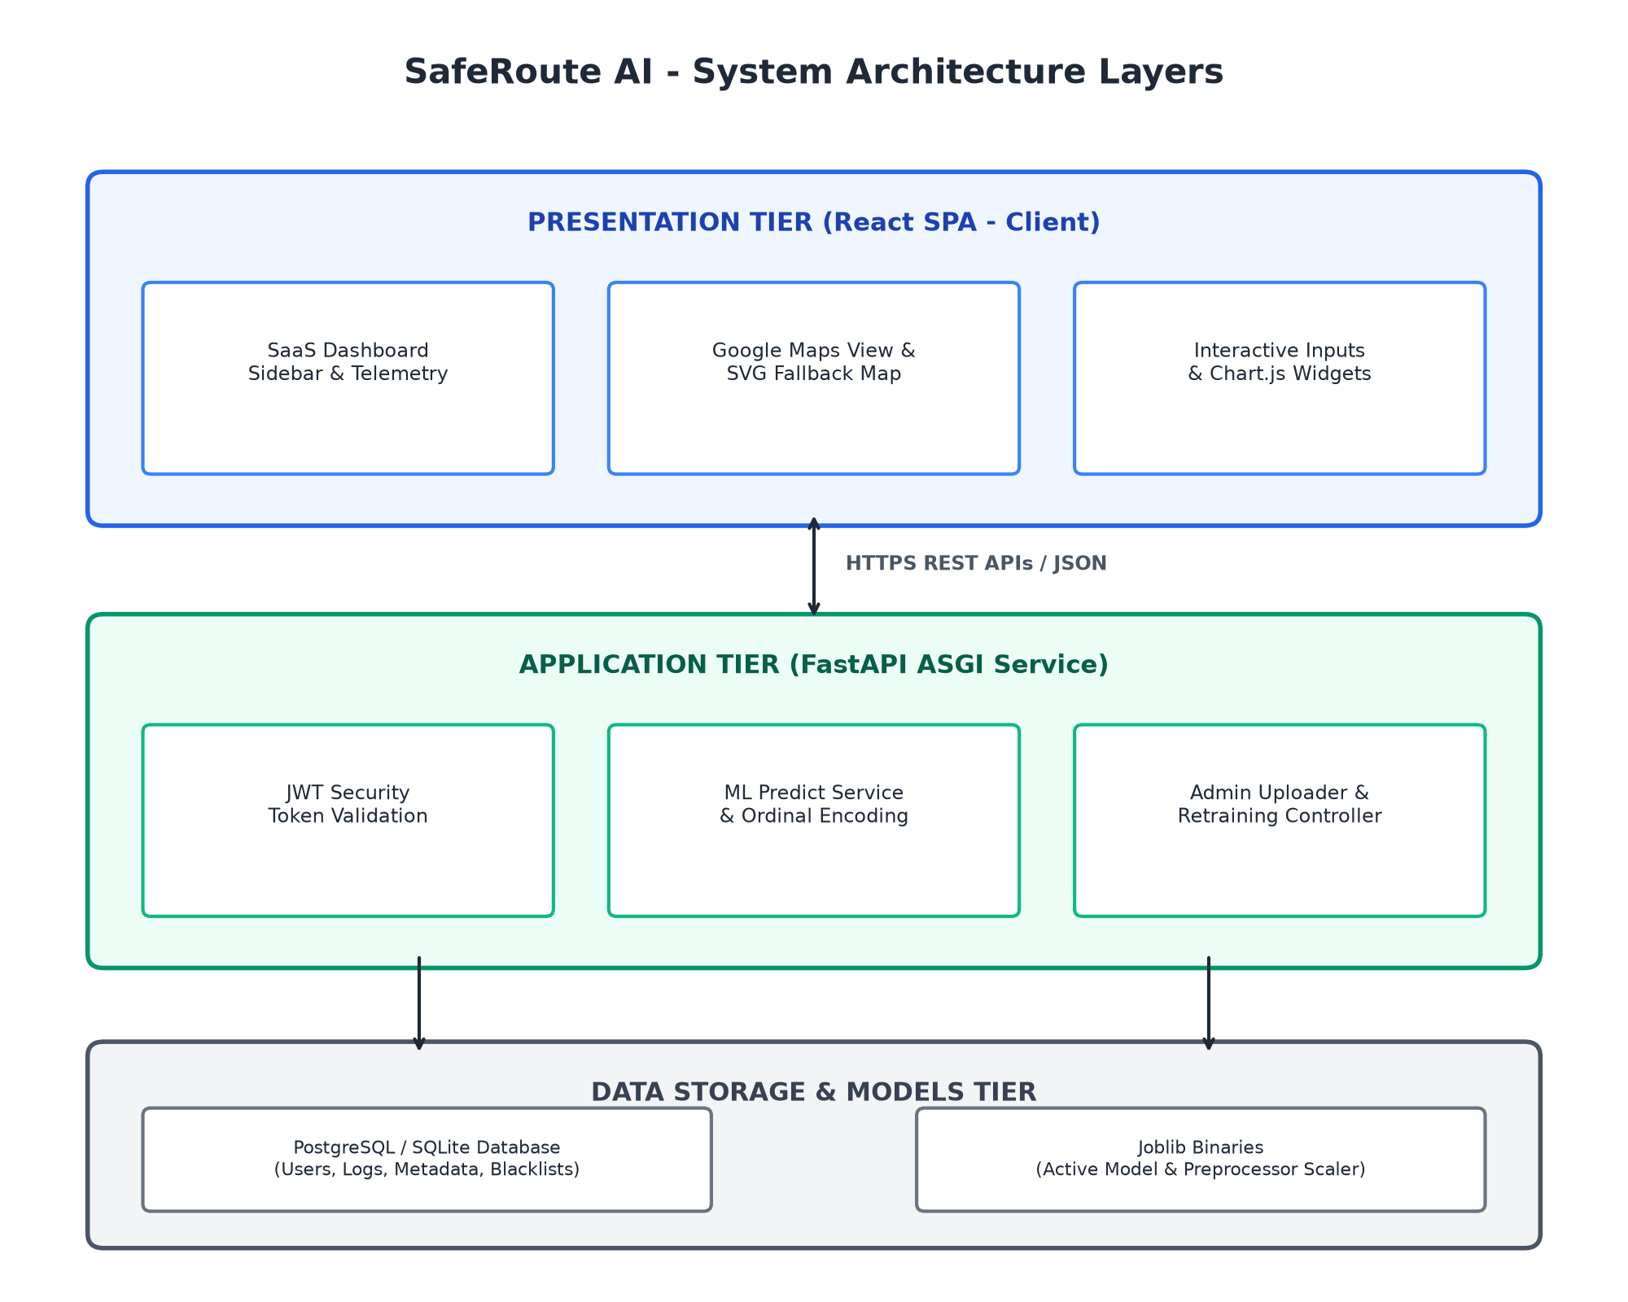
Figure 4.1 - SafeRoute AI System Architecture Context Diagram
4.2 User Journey & Process Workflow Flowchart
The user journey begins at `/login`. After successful authentication, they access `/dashboard` where Google Maps loads in dark mode. The user inputs travel parameters, and the backend returns a prediction payload containing the risk score, category, and confidence. The client visualizes the risk using map overlays and stores the prediction in the database history.
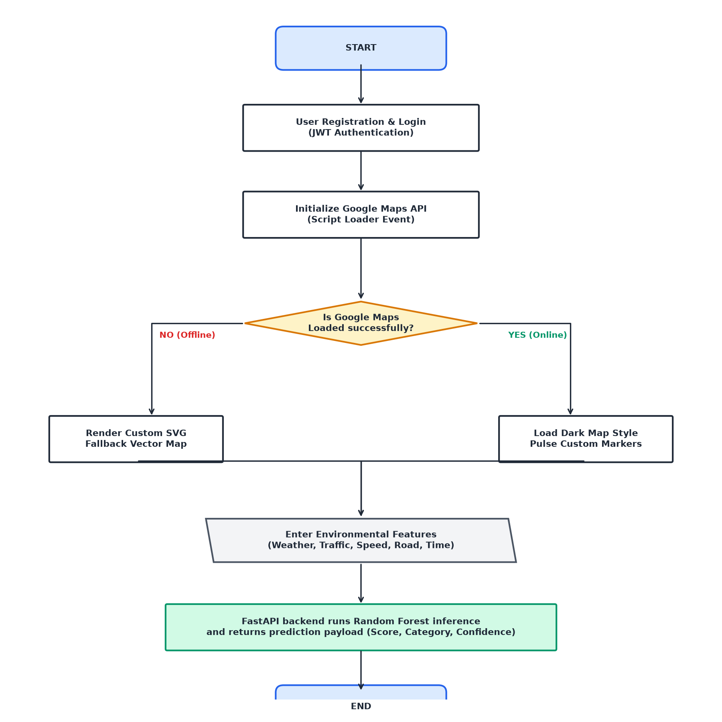
Figure 4.2 - SafeRoute AI Process Workflow Flowchart
4.3 Functional Module Decomposition & Interactions
The platform is divided into five distinct core modules. The User Authentication module checks session validity. The Map module initializes map interfaces. The Prediction module executes risk assessments. The Dataset Upload module accepts CSV training files, and the Model Retraining module handles model updates.
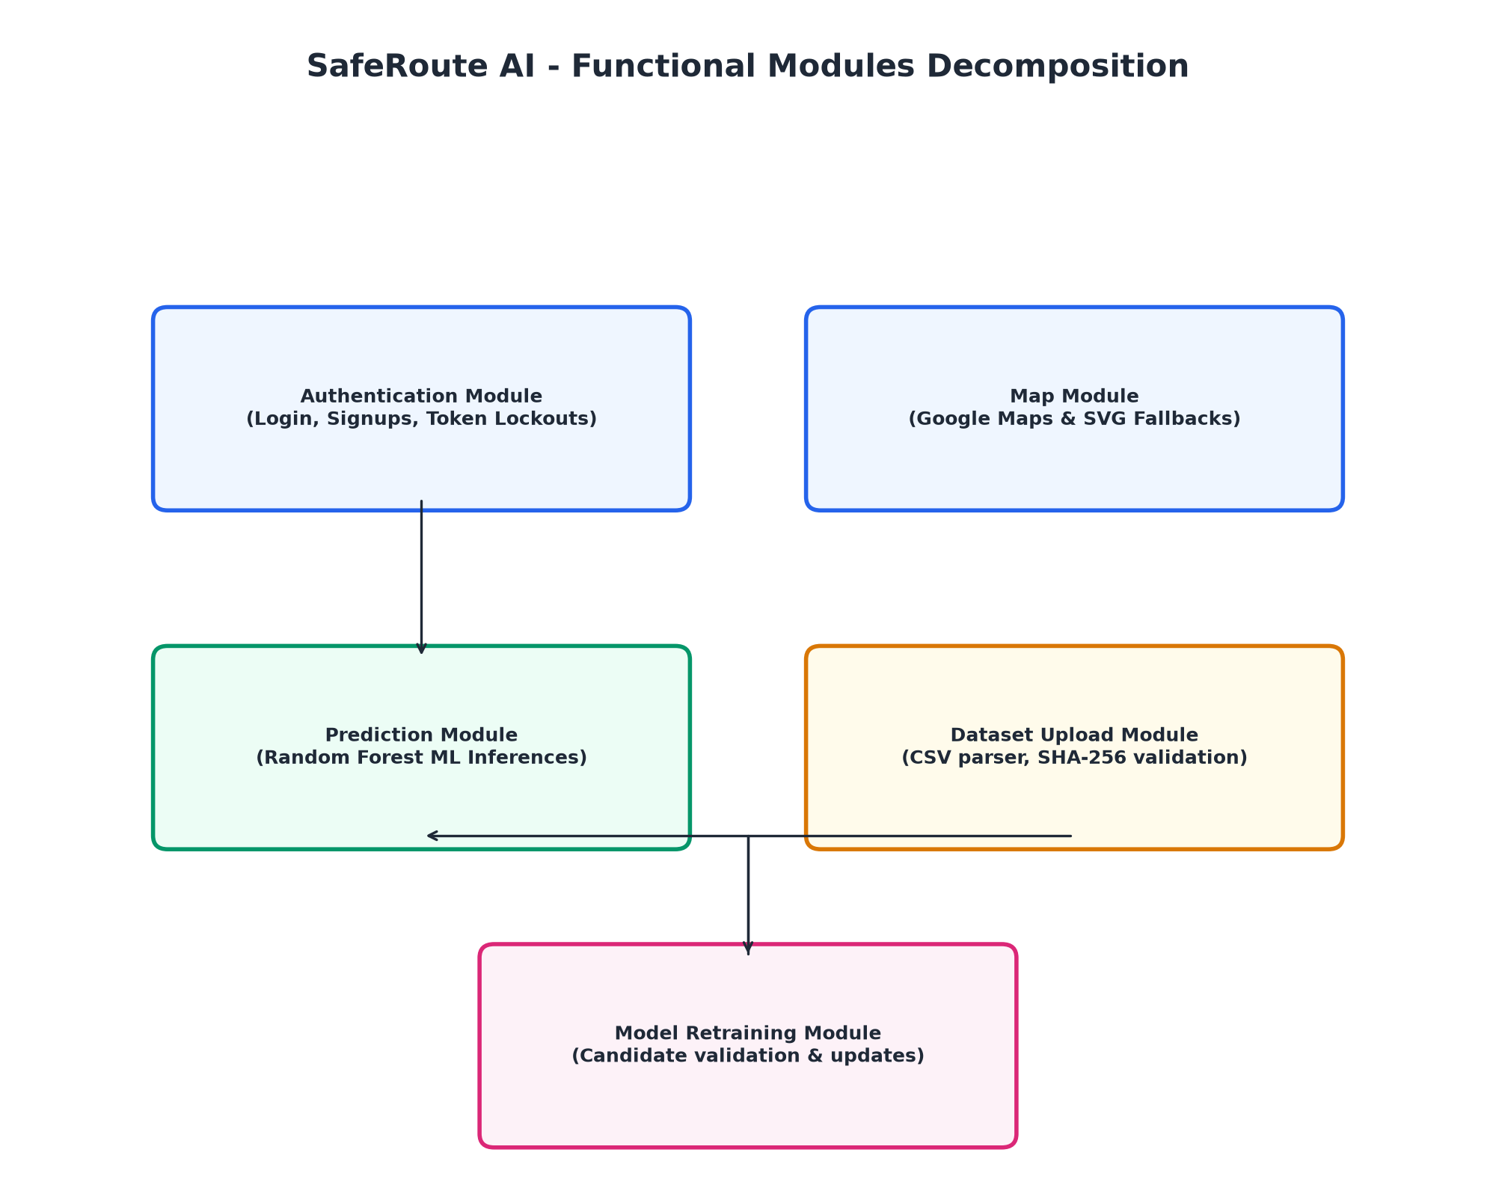
Figure 4.3 - SafeRoute AI Functional Modules Decomposition
4.4 Database Schema & Table Specifications
The database design uses a relational model to store user profiles, prediction logs, dataset metadata, and audit records. The schema utilizes foreign keys to link tables and index key columns to speed up queries.
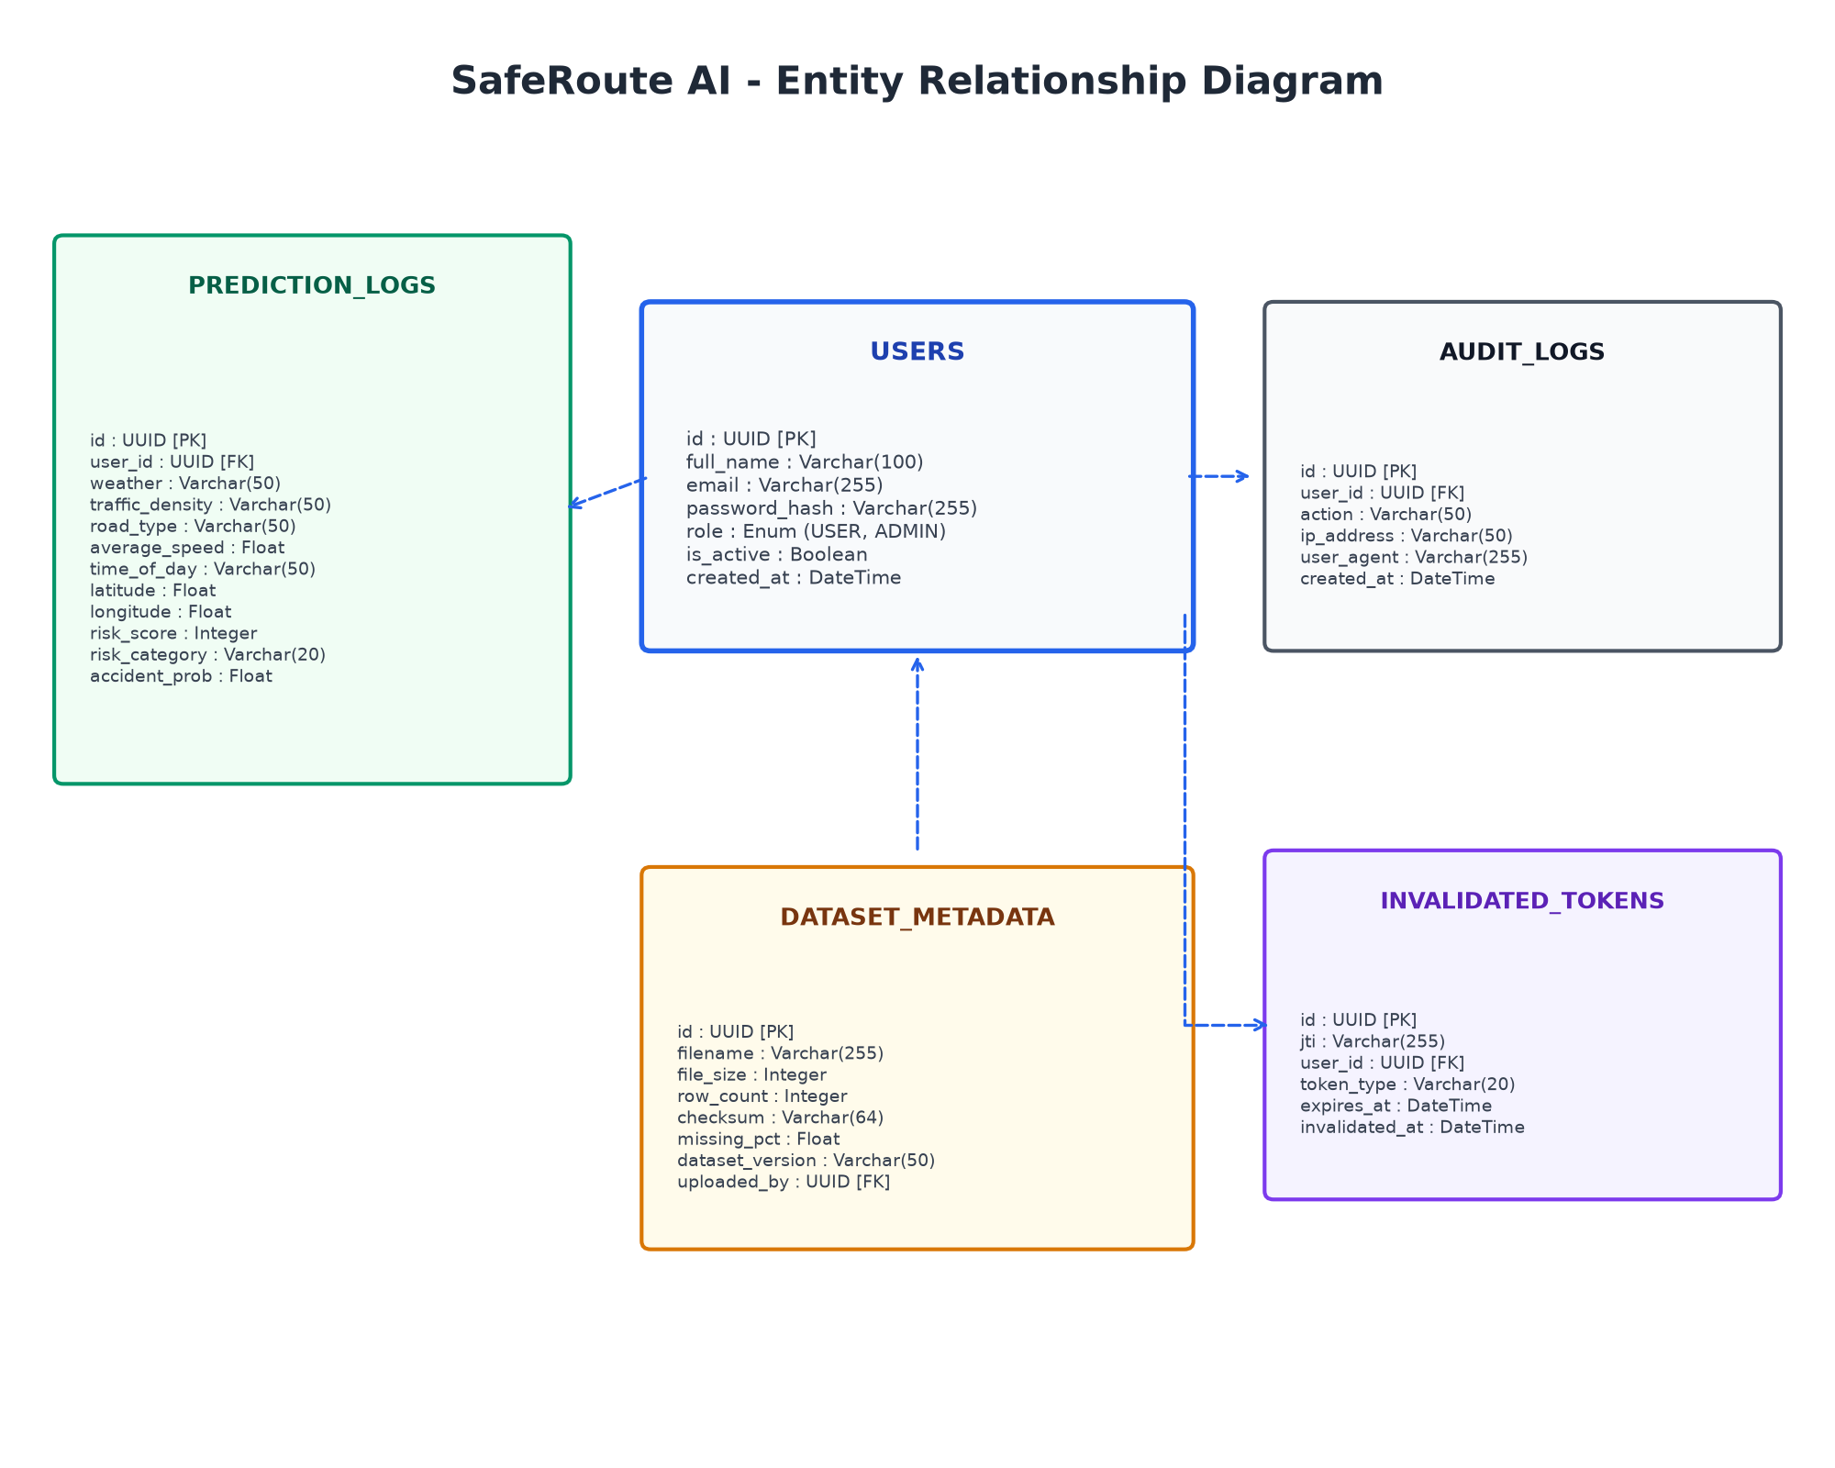
Figure 4.4 - Entity Relationship Diagram
Table 3.1 Users
Field Name | Data Type | Description
id | UUID (PK) | Unique user identifier
full_name | Varchar(100) | Full name of the user
email | Varchar(255) | Unique login email address
password_hash | Varchar(255) | Bcrypt hashed password
role | Enum (USER, ADMIN) | User authorization level
is_active | Boolean | User status indicator
created_at | DateTime | Timestamp of account registration
Table 3.2 PredictionLogs
Field Name | Data Type | Description
id | UUID (PK) | Unique prediction log identifier
user_id | UUID (FK) | References Users table
weather | Varchar(50) | Weather inputs (Rainy, Clear, etc.)
traffic_density | Varchar(50) | Traffic inputs (High, Jammed, etc.)
road_type | Varchar(50) | Road type inputs (Highway, etc.)
average_speed | Float | Average speed parameter
time_of_day | Varchar(50) | Time inputs (Night, Morning, etc.)
latitude | Float | Latitude coordinates of hotspot
longitude | Float | Longitude coordinates of hotspot
risk_score | Integer | Risk score result (0-100)
risk_category | Varchar(20) | Low, Medium, High, Critical
accident_probability | Float | Confidence score percentage
Table 3.3 DatasetMetadata
Field Name | Data Type | Description
id | UUID (PK) | Unique dataset upload identifier
filename | Varchar(255) | Name of the uploaded CSV file
file_size | Integer | Size of file in bytes
row_count | Integer | Number of training sample rows
checksum | Varchar(64) | SHA-256 integrity hash
missing_percentage | Float | Percentage of null elements in file
dataset_version | Varchar(50) | Semantic version number
uploaded_by | UUID (FK) | References Users table
Table 3.4 AuditLogs
Field Name | Data Type | Description
id | UUID (PK) | Unique audit log identifier
user_id | UUID (FK) | References Users table
action | Varchar(50) | Performed administrative action
ip_address | Varchar(50) | IP of client requester
user_agent | Varchar(255) | User Agent of requester
created_at | DateTime | Action execution timestamp
Table 3.5 InvalidatedTokens
Field Name | Data Type | Description
id | UUID (PK) | Unique token log identifier
jti | Varchar(255) | Unique token identifier stored in db
user_id | UUID (FK) | References Users table
token_type | Varchar(20) | Access or Refresh token description
expires_at | DateTime | Expiration timestamp of token
invalidated_at | DateTime | Blacklisting timestamp of token

CHAPTER 5 - Future Product Evolution Roadmap
SafeRoute AI is designed with modularity to accommodate future feature releases and enhancements without major modifications.
Dynamic Route Routing & GPS integration
Future releases can include dynamic routing algorithms that leverage predicted safety scores. Instead of calculating the fastest path, the routing engine will calculate the safest path, avoiding predicted hotspots. We can design cost functions that balance travel time and accident probability.
Live Traffic Speed Telemetries
Integrating with live speed feeds—like TomTom Live API, HERE Maps API, or municipal speed sensors—will replace the manual speed and traffic density selectors, updating risk assessments dynamically as traffic patterns shift.

Computer Vision Hazard Detections
Integrating with live CCTV feeds can enable computer vision models to detect hazards (like potholes or waterlogging) and automatically generate glowing hotspots, alerting drivers in real time.
Mobile Client Platforms
Building dedicated mobile apps for iOS and Android will allow users to receive real-time notifications, saved location alerts, and voice queries during transit.
CHAPTER 6 - Retrospective Conclusion
This Software Requirement Specification (SRS) document defines the system requirements and specifications for SafeRoute AI: An AI-Powered Road Accident Hotspot Prediction System.
By utilizing a Random Forest Classifier, dark-themed maps, and an SVG fallback, SafeRoute AI provides a reliable, proactive road safety platform. The system's decoupled architecture ensures scalability, maintainability, and support for future enhancements, providing a solid foundation for development.

